

**Assignment Cover Sheet**

|  |  |  |  |  |  |  |
| --- | --- | --- | --- | --- | --- | --- |
| **Student name:** | **Sarah Narayamy Tavares Silva** | | | | | |
| **Student number:** | **2960992** | | |  | | |
| **Faculty:** | **Computing Science** | | |  | | |
| **Course:** | **Computing Science** | | | **Stage/year:** | **3** | |
| **Subject:** | **Networks and Data Communications** | | | | | |
| **Study Mode:** | Full time | **X** |  | Part-time |  |  |
| **Lecturer Name:** | **Brendan Fogarty** | | | | | |
| **Assignment Title:** | **Tutorial Sheet 4** | | | | | |
| **No. of pages:** | **7** | | |  | | |
| **Disk included?** | Yes |  |  | No | **X** |  |
| **Additional Information:** | (ie. number of pieces submitted, size of assignment, A2, A3 etc) | | | | | |
|  | | | | | |
|  | | | | | |
| **Date due:** | **15/12/2019** | | |  | | |
| **Date submitted:** | **14/12/2019** | | |  | | |
|  | | | | | | |
| **Plagiarism disclaimer:**  *I understand that plagiarism is a serious offence and have read and understood the college policy on plagiarism. I also understand that I may receive a mark of zero if I have not identified and properly attributed sources which have been used, referred to, or have in any way influenced the preparation of this assignment, or if I have knowingly allowed others to plagiarise my work in this way.*  *I hereby certify that this assignment is my own work, based on my personal study and/or research, and that I have acknowledged all material and sources used in its preparation. I also certify that the assignment has not previously been submitted for assessment and that I have not copied in part or whole or otherwise plagiarised the work of anyone else, including other students.*  **Signed: Sarah Narayamy Tavares Silva Date: 14/12/2019** | | | | | | |

## **Please note:** Students **MUST** retain a hard / soft copy of **ALL** assignments as well as a receipt issued and signed by a member of Faculty as proof of submission.

**Question 01: Encoding**

**Discuss any three desirable properties of an encoding scheme.**

A good encoding scheme must consider a few properties. One of them is evaluate the complexity of the scheme; ideally, an encoding scheme should be as simple as possible and as easier to implement in hardware and/or software, hence, the lower is the complexity, the lower is the cost.

In relation to Resistance of Noise, an encoding scheme should preferably perform well in noisy environments.

About the Clocking property, a good encoding scheme should ideally be self clocking.

**Question 2: In relation to encoding schemes explain the following terms:**

**- Bit Window**

**- DC Component**

**- Clock**

**- Synchronisation**

**Please Note: - Use diagrams where appropriate to enhance your solution**

A bit window is the time period in which a bit is represented. DC Component is when the code stays the same for a certain amount of time. Clock is a repeating signal used to keep sender and receiver synchronised. With a clock, the receiver knows the start and end of each bit window. Synchronisation is when sender and receiver are on the same page to know when does each bit window starts and end.

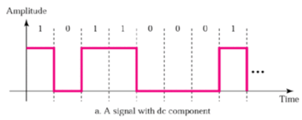

**Question 3: Some encoding schemes rely on the RX to interpret the encoded signal solely based on the voltage level. Give an example of such an encoding scheme and explain how a received signal may be mis-interpreted.**

NRZ is an example of an encoding scheme that relies only on the voltage level. Thus, when there is a “0”, it is encoded as negative voltage (-5v) and when is “1”, it is encoded as a positive voltage (+5v). However, when we have a sequence of zeros or a sequence of ones, the encode scheme would represent it as it is called DC component which is when the code stays the same causing distortion at the receiver end.

**Question 4: Some encoding schemes rely on the RX to interpret the encoded signal based on the difference in voltage levels (between adjacent bit windows) Give an example of such an encoding scheme and explain why a received signal is more likely to be interpreted correctly.**

Non Return to Zero Inverted (NRZI) encoding scheme is an example of a scheme that is based on the difference in voltage levels between adjacent bit windows, once a “0” is encoded as not having a transition at the start of the bit window and a “1” is encoded by transitioning at the start of bit window and it will vary according to the previous “1” voltage level, going from high (positive / +5v) to low (negative / -5v). For example, if the first 1 was set to +5v, the second “1” would be set to -5v. The fact that it does rely solely on the difference in voltage levels makes it more likely to be interpreted correctly.

**Question 5: Encode the following bit pattern 10100111 using NRZ. Please Note:**

**- State clearly in your answer how a ‘0’ is encoded and how a ‘1’ is encoded**

**- You must label all axes clearly.**

Amplitude

|  |  |  |  |  |  |  |  |  |
| --- | --- | --- | --- | --- | --- | --- | --- | --- |
|  | 1 | 0 | 1 | 0 | 0 | 1 | 1 | 1 |
| +5 |  |  |  |  |  |  |  |  |
| 0 |  |  |  |  |  |  |  |  |
| -5 |  |  |  |  |  |  |  |  |

Time

In the NRZ scheme, the pulse is represented by: 0 encoded as negative voltage (-5v) and 1 is represented as positive voltage (+5v) and never returning to zero voltage.

**Question 6: What advantages does the Manchester encoding scheme offer over other simpler schemes such as NRZ for example. Use the bit pattern 00001111 as the basis for your discussion.**

The Manchester encoding scheme does not rely on just voltage levels in order to transmit a message. It has the advantage of always transitioning in the middle of a bit window which is interpreted by Rx. This scheme is also resistant to noise and there is no DC component which is when the code stays the same. On the other hand, NRZ encoding scheme is based on voltage levels, in which a 0 is encoded as negative voltage (-5v) and 1 is encoded as positive voltage (+5v). Bellow there is a representation of the difference between NRZ and Manchester encoding schemes with the same bit pattern.

Manchester

Amplitude

|  |  |  |  |  |  |  |  |  |  |  |  |  |  |  |  |  |
| --- | --- | --- | --- | --- | --- | --- | --- | --- | --- | --- | --- | --- | --- | --- | --- | --- |
|  | 0 | | 0 | | 0 | | 0 | | 1 | | 1 | | 1 | | 1 | |
| +5 |  |  |  |  |  |  |  |  |  |  |  |  |  |  |  |  |
| 0 |  |  |  |  |  |  |  |  |  |  |  |  |  |  |  |  |
| -5 |  |  |  |  |  |  |  |  |  |  |  |  |  |  |  |  |

Time

NRZ

Amplitude

|  |  |  |  |  |  |  |  |  |
| --- | --- | --- | --- | --- | --- | --- | --- | --- |
|  | 0 | 0 | 0 | 0 | 1 | 1 | 1 | 1 |
| +5 |  |  |  |  |  |  |  |  |
| 0 |  |  |  |  |  |  |  |  |
| -5 |  |  |  |  |  |  |  |  |

Time

**Question 7: Expand the last two digits of your student number into 2 x four-bit numbers. e.g. 01 → 00000001 Encode the resultant bit pattern using the Differential Manchester encoding scheme Please Note:**

**- State clearly in your answer how a ‘0’ is encoded and how a ‘1’ is encoded**

**- You must label all axes clearly**

92 is the last two digits of my student number which is 01011100

Amplitude

|  |  |  |  |  |  |  |  |  |  |  |  |  |  |  |  |  |
| --- | --- | --- | --- | --- | --- | --- | --- | --- | --- | --- | --- | --- | --- | --- | --- | --- |
|  | 0 | | 1 | | 0 | | 1 | | 1 | | 1 | | 0 | | 0 | |
| +5 |  |  |  |  |  |  |  |  |  |  |  |  |  |  |  |  |
| 0 |  |  |  |  |  |  |  |  |  |  |  |  |  |  |  |  |
| -5 |  |  |  |  |  |  |  |  |  |  |  |  |  |  |  |  |

Time

The differential Manchester encoding scheme states that there is always a transition in the middle of the bit window, a 0 is represented by also transitioning at the start of the bit window and a 1 is represented by not transitioning at the start of the bit window.

**Question 8: The following signal was generated using the AMI encoding scheme, decode the signal to recover the original bit pattern.**

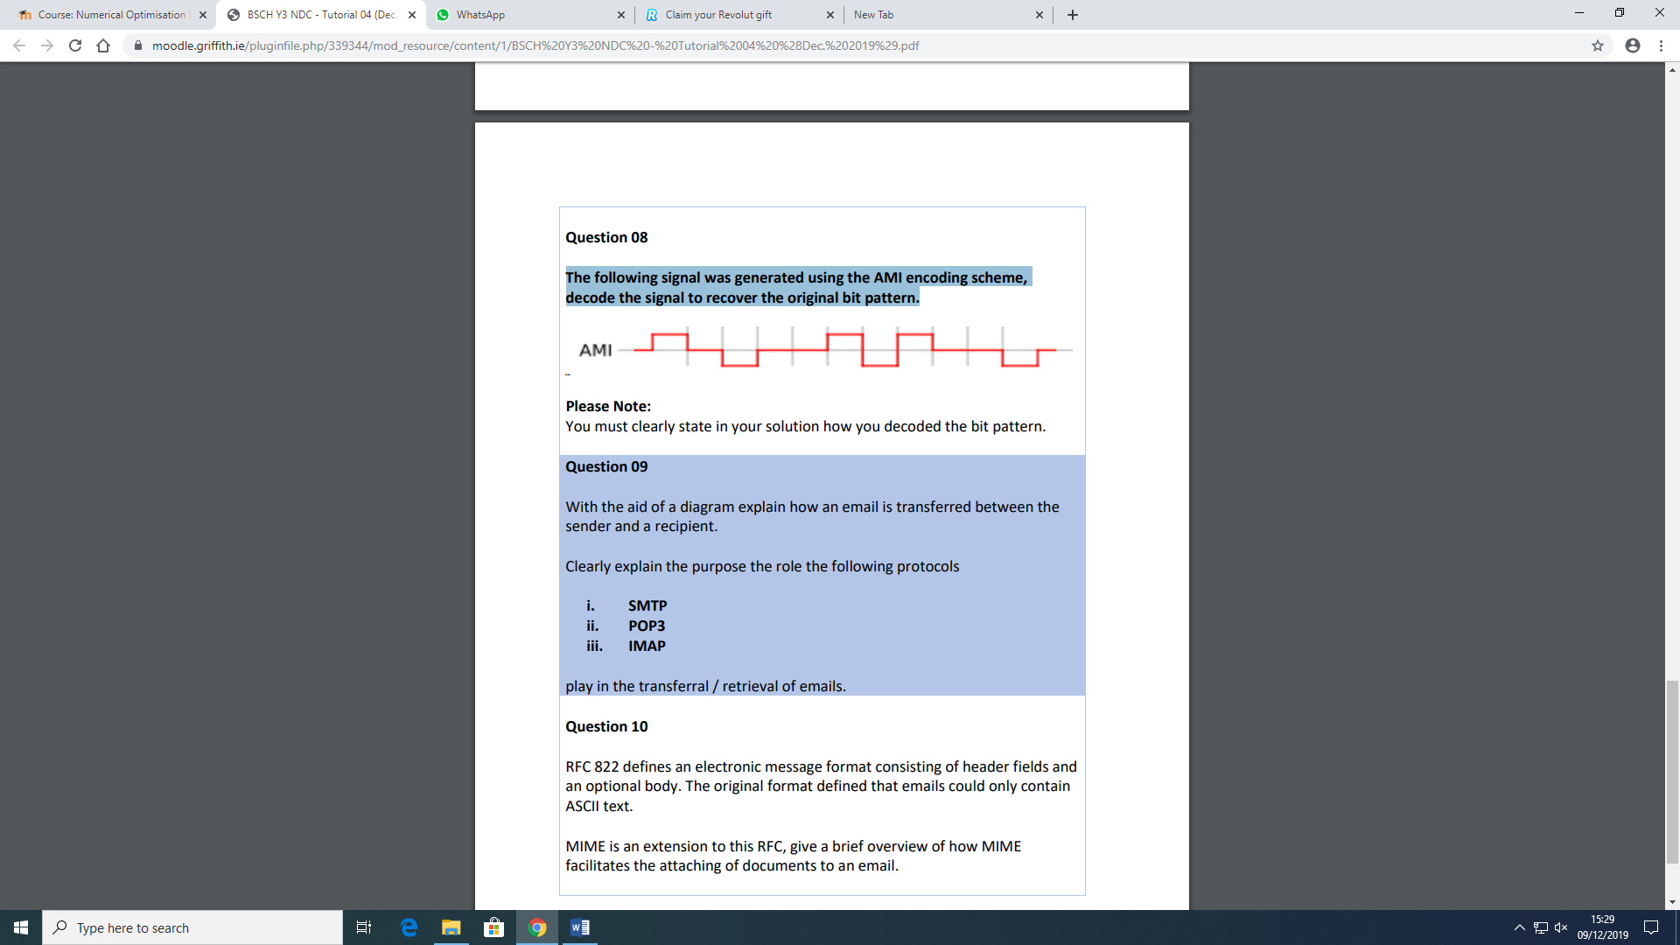

**Please Note: You must clearly state in your solution how you decoded the bit pattern.**

0101001110010

In AMI encoding scheme, a zero is always encoded as 0 voltage, while 1 is encoded as either positive voltage (+5) or negative voltage (-5) depending on the previous 1 voltage level. Thus, considering the beginning as the first bit window starting at 0 voltage, the bit pattern encoded represents the following: 0101001110010

**Question 9: With the aid of a diagram explain how an email is transferred between the sender and a recipient. Clearly explain the purpose the role the following protocols**

1. **SMTP**
2. **POP3**
3. **IMAP**

**play in the transferral / retrieval of emails.**

When someone writes a message, usually using outlook, this email is specially formatted to be transmitted over the internet using the Simple Mail Transfer Protocol (SMTP), who looks into the recipient’s domain name (@gmail.com) to determine which destination mail server is should contact to deliver the message.

The sending and receiving servers use the SMTP protocol to communicate with each other and when the receiving server accepts the message, it can be delivered to the recipient. The recipient’s email now uses standards like the Post Office Protocol (POP) or the Internet Message Access Protocol (IMAP) to retrieve the message and download the message in a way that it can be read.

When POP protocol is used to retrieve an email, the email is downloaded locally and deleted from the server, which means that the email can only be viewed on the machine it was downloaded to. When IMAP protocol is used, emails are stored on server until it is deleted or you exceed your storage limit. Emails can be viewed simultaneously across multiple devices and are not downloaded locally.

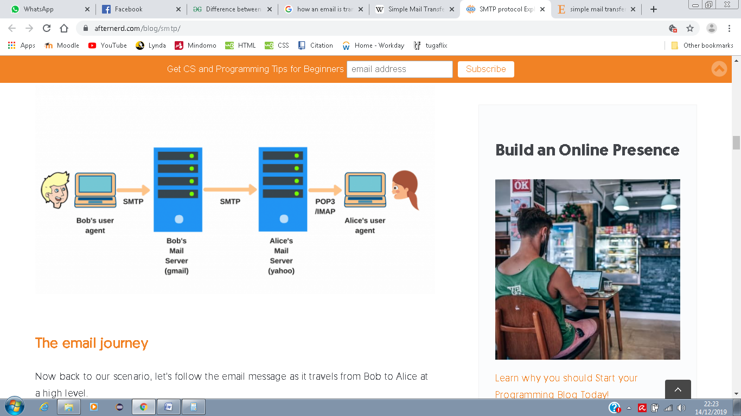

**Question 10: RFC 822 defines an electronic message format consisting of header fields and an optional body. The original format defined that emails could only contain ASCII text.**

**MIME is an extension to this RFC, give a brief overview of how MIME facilitates the attaching of documents to an email.**

MIME works as an adds-on or a supplementary encoding information protocol. This protocol allows non-ASCII data to be sent through the network. MIME transforms non-ASCII data from sender to NVT 7-bit data and delivers it to the recipient. When the message gets to the receiver, it is transferred back to its original data.

